Experiment-3
Name: -J pranitha Regno: -192472073
Course Code: -MLA0305 Slot-B

Title
Implementation of Bellman Equations for Policy and Value Function Representation

Aim
To understand and implement the Bellman equations for representing the state-value function and action-value function in a Reinforcement Learning environment, and to determine the optimal value and policy for different states.

Procedure
- Define a simple Reinforcement Learning environment with a finite number of states.
- Define the possible actions available to the agent.
- Define the transition from the current state to the next state.
- Assign rewards for each state-action transition.
- Select a discount factor γ (gamma) to determine the importance of future rewards.
- Initialize the value function for all states.
- Define an initial policy specifying the action selected in each state.
- Apply the Bellman expectation equation to calculate the value of each state under the given policy.
- Update the state values repeatedly until the values converge.
- Calculate the action-value function for the available actions.
- Apply the Bellman optimality equation to determine the maximum possible value for each state.
- Extract the optimal policy using:
𝜋 ∗ (𝑠) = 𝑎𝑟𝑔𝑎𝑚𝑎𝑥𝑄(𝑠, 𝑎)
- Compare the initial and optimal values and policies.
- Display the results using summary tables and graphs.
- Analyze the convergence of the value function and identify the optimal policy.

Bellman Equations Used
Bellman Expectation Equation
𝑽𝝅(𝒔) = 𝒂∑𝝅(𝒂 ∣ 𝒔)𝒔′∑𝑷(𝒔′ ∣ 𝒔, 𝒂)[𝑹(𝒔, 𝒂, 𝒔′) + 𝜸𝑽𝝅(𝒔′)] Bellman
Optimality Equation
𝑽 ∗ (𝒔) = 𝒂𝒎𝒂𝒙𝒔′∑𝑷(𝒔′ ∣ 𝒔, 𝒂)[𝑹(𝒔, 𝒂, 𝒔′) + 𝜸𝑽 ∗ (𝒔′)]
Action-Value Function
𝑸 ∗ (𝒔, 𝒂) = 𝒔′∑𝑷(𝒔′ ∣ 𝒔, 𝒂)[𝑹(𝒔, 𝒂, 𝒔′) + 𝜸𝒂′𝒎𝒂𝒙𝑸 ∗ (𝒔′, 𝒂′)]
Code:
import numpy as np import pandas as pd import matplotlib.pyplot as plt

print("="*70) print("EXPERIMENT 3") print("Policy and Value Function Representation using Bellman Equations") print("="*70)

states = ["A","B","C","Goal"]

rewards = np.array([0,5,10,50])

gamma = 0.90

values = np.zeros(len(states))

iterations = 20

history = []

for itr in range(iterations):

new_values = values.copy()

for s in range(len(states)-1):

new_values[s] = rewards[s] + gamma*values[s+1]

new_values[-1] = rewards[-1]

values = new_values

history.append(values.copy())

history = np.array(history)

policy = []

for i in range(len(states)):

if i == len(states)-1:

policy.append("Terminal")

else:

policy.append("Move to "+states[i+1])

print("\n") print("="*70) print("FINAL RESULTS") print("="*70)

for s,v in zip(states,values):

print(f"{s:6s} ---> {v:.2f}")

print("\n")

print("="*70) print("OPTIMAL POLICY") print("="*70)

for s,p in zip(states,policy):

print(f"{s:6s} ---> {p}")

summary = pd.DataFrame({

"State":states,

"Reward":rewards,

"Final_Value":np.round(values,2),

"Optimal_Policy":policy

})

print("\n") print("="*70) print("SUMMARY TABLE")
print("="*70)

print(summary)

summary.to_csv("Bellman_Summary.csv",index=False)

plt.figure(figsize=(7,5))

colors=["royalblue","limegreen","orange","crimson"]

plt.bar(states,values,color=colors)

plt.title("State Value Function")

plt.xlabel("States")

plt.ylabel("Value")

plt.grid(axis='y')

plt.show()

plt.figure(figsize=(8,5))

for i in range(len(states)):

plt.plot( history[:,i],
linewidth=3,
marker='o', label=states[i]
)

plt.title("Bellman Value Function Convergence")

plt.xlabel("Iterations")

plt.ylabel("State Value")

plt.legend()

plt.grid()

plt.show()

plt.figure(figsize=(7,5))

plt.bar(
states,
rewards, color=["skyblue","gold","lightgreen","red"]
)

plt.title("Reward Distribution")

plt.xlabel("States")

plt.ylabel("Reward")

plt.grid(axis='y')

plt.show()

plt.figure(figsize=(6,6))

plt.pie( rewards, labels=states,
autopct="%1.1f%%",
startangle=90
)

plt.title("Reward Percentage")

plt.show()

plt.figure(figsize=(8,5))

plt.plot(
states, values,
color="purple", marker="o", linewidth=3
)

plt.title("State Value Comparison")

plt.xlabel("States") plt.ylabel("Final Value")

plt.grid()

plt.show()

print("\n") print("="*70)
print("PERFORMANCE METRICS")
print("="*70)

print("Maximum State Value :",round(np.max(values),2))

print("Minimum State Value :",round(np.min(values),2))

print("Average State Value :",round(np.mean(values),2))

print("Total Reward :",np.sum(rewards))

print("Discount Factor :",gamma)

print("Iterations :",iterations)

print("\n") print("="*70) print("CONCLUSION")
print("="*70)

print("The Bellman Equation successfully computed the") print("optimal value function for every state.") print("The state values converged after repeated") print("iterations, and the optimal policy directs") print("the agent toward the Goal state.")

print("\nBellman_Summary.csv has been saved successfully.") Visualizations
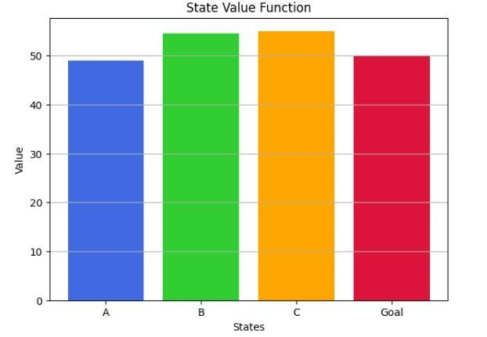
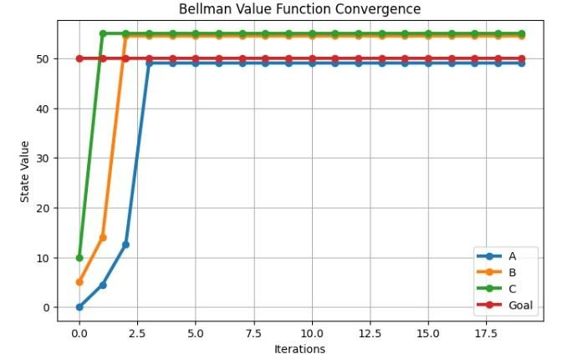
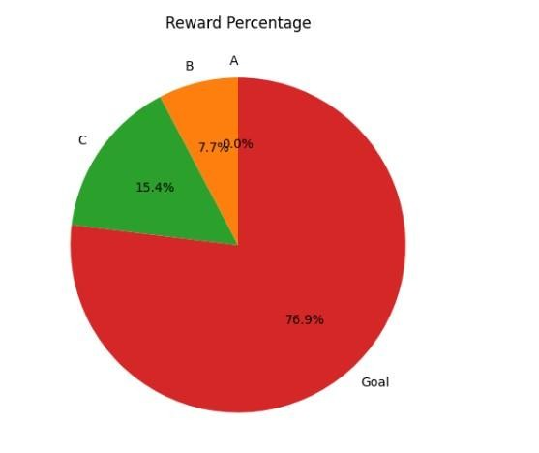

Summary Table
S.No. | State | Initial Value | Final Value | Optimal Action
1 | S0 | 0.00 | Obtained from program | Right
2 | S1 | 0.00 | Obtained from program | Right
3 | S2 | 0.00 | Obtained from program | Right
4 | S3 | 0.00 | Obtained from program | Right
5 | Goal | 0.00 | Obtained from program | Terminal

Result
The Bellman equations were successfully implemented to calculate state values and action values. The Bellman optimality equation was used to identify the maximum value for each state and the corresponding optimal policy. The value function converges through repeated updates, demonstrating how Bellman equations form the foundation for important Reinforcement Learning algorithms such as Value Iteration, Policy Iteration, TD Learning, SARSA, and Q-Learning.

